SF.SmokeTestScripts_TC_SF_OBRequiredFieldsOnSalesStage_Instance1_12-Apr-2017_10-06-49_PM_Invoke_Application.png



SF.SmokeTestScripts_TC_SF_OBRequiredFieldsOnSalesStage_Instance1_12-Apr-2017_10-07-00_PM_Login.png

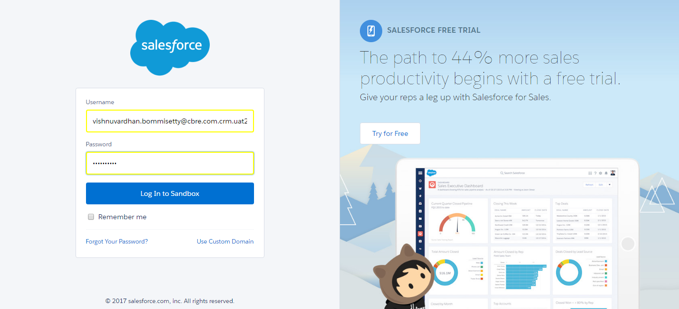

SF.SmokeTestScripts_TC_SF_OBRequiredFieldsOnSalesStage_Instance1_12-Apr-2017_10-07-14_PM_Verify_Login.png

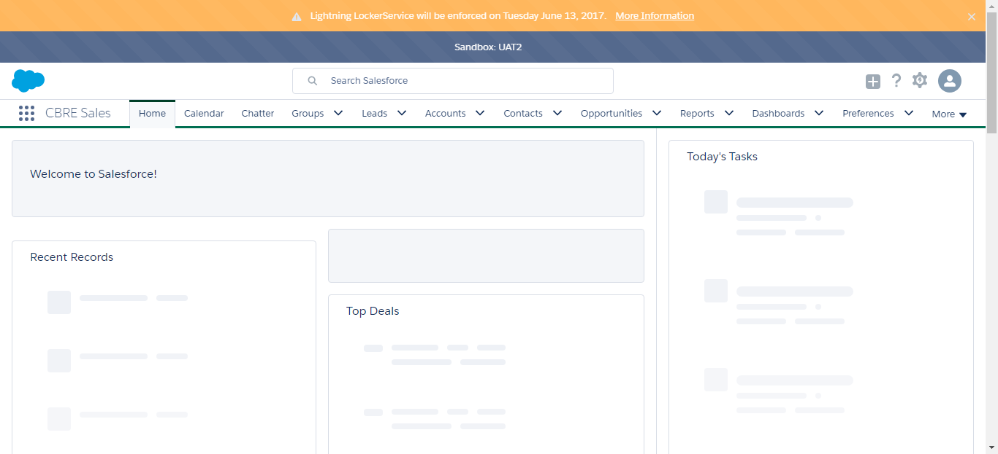

SF.SmokeTestScripts_TC_SF_OBRequiredFieldsOnSalesStage_Instance1_12-Apr-2017_10-07-16_PM_Verify_Fetch_Record.png

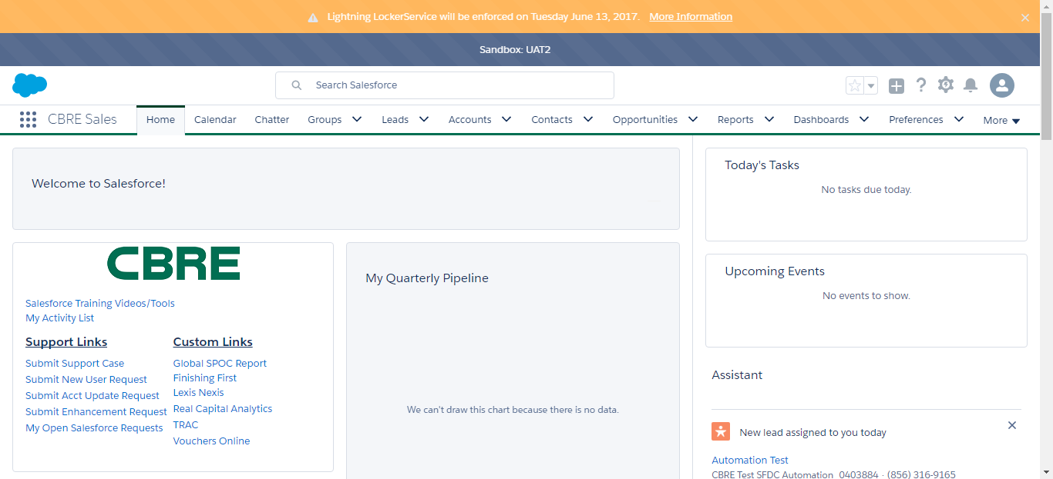

SF.SmokeTestScripts_TC_SF_OBRequiredFieldsOnSalesStage_Instance1_12-Apr-2017_10-07-21_PM_Verify_Add_Opportunity_Page



SF.SmokeTestScripts_TC_SF_OBRequiredFieldsOnSalesStage_Instance1_12-Apr-2017_10-07-21_PM_Verify_Opportunity_Required



SF.SmokeTestScripts_TC_SF_OBRequiredFieldsOnSalesStage_Instance1_12-Apr-2017_10-07-40_PM_Verify_Add_Opportunity_Page

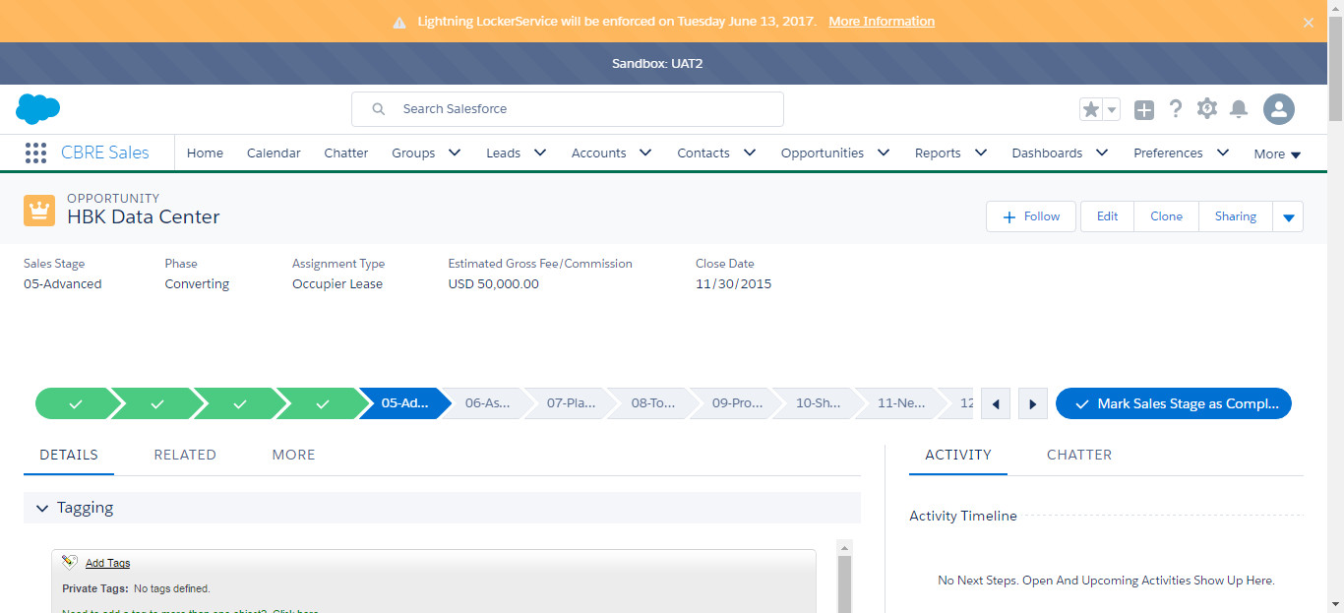

SF.SmokeTestScripts_TC_SF_OBRequiredFieldsOnSalesStage_Instance1_12-Apr-2017_10-11-10_PM_Verify_Fetch_Record.png

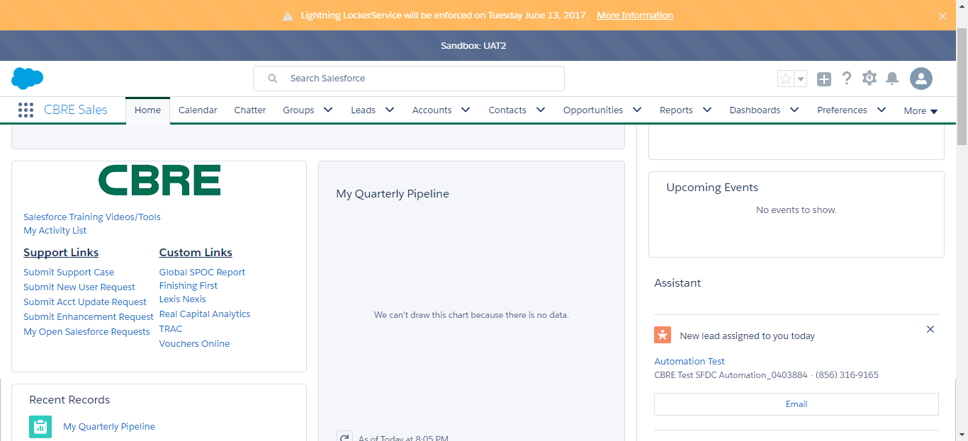

SF.SmokeTestScripts_TC_SF_OBRequiredFieldsOnSalesStage_Instance1_12-Apr-2017_10-11-14_PM_Verify_Opportunity_Required



SF.SmokeTestScripts_TC_SF_OBRequiredFieldsOnSalesStage_Instance1_12-Apr-2017_10-11-15_PM_Verify_Add_Opportunity_Page



SF.SmokeTestScripts_TC_SF_OBRequiredFieldsOnSalesStage_Instance1_12-Apr-2017_10-11-40_PM_Error.png

